|  |  |  |
| --- | --- | --- |
|  |  | |
|  | Riverview Park Residents Association  **www.riverview-park-residents-assoc.com** | |
|  | e-Newsletter October 2022 | |
| **In This Issue**   * Onsite Updates * SCOPHRA Updates * Community Garden   e-newsletter :  Welcome to our  e-newsletter.  In a bid to cut down on paper and ink costs, also to reduce recycling, we are hoping that residents will use this version of newsletter. For residents who do not have internet access we still deliver a paper version so all residents on Riverview are kept up to date with onsite news.  Contact Us :  Secretary  Bill Gray 1 Grosvenor Park  Tel: 07872498494  billgray479@btinternet.com  **www.riverview-park-residents-assoc.com** | A picture containing diagram  Description automatically generatedA picture containing diagram  Description automatically generatedA picture containing diagram  Description automatically generated A picture containing diagram  Description automatically generated  Text  Description automatically generated Jeanette held a successful 2-day coffee morning.  The weather wasn’t the best, but the event was well supported.  An amazing £340 was raised. Thanks to all.  October is the tenth month of the year in the Julien and Gregorian calendars and the sixth of seven months to have a length of 31 days. The eighth month in the old calendar of Romulus c.750BC October retained its name (from Latin and Greek ôctō meaning "eight") after January and February were inserted into the calendar that had originally been created by the Romans.  A picture containing text  Description automatically generated    Halloween originated as a practice of the Celts at the end of their summer season, when they celebrated the harvest. Known as Samhain over 2000 years ago, they believed that on that night ghosts of the dead returned to earth to wreak havoc on their crops and possess the living.  So costumes were worn to trick the evil spirits into thinking that the people were other evil spirits. Thus, the legend began | |
|  | |

We now have a RPRA Facebook page. If you wish to join this group, go to

Facebook, and look up Riverview Park Residents Association and ask

Admin to add you to the group

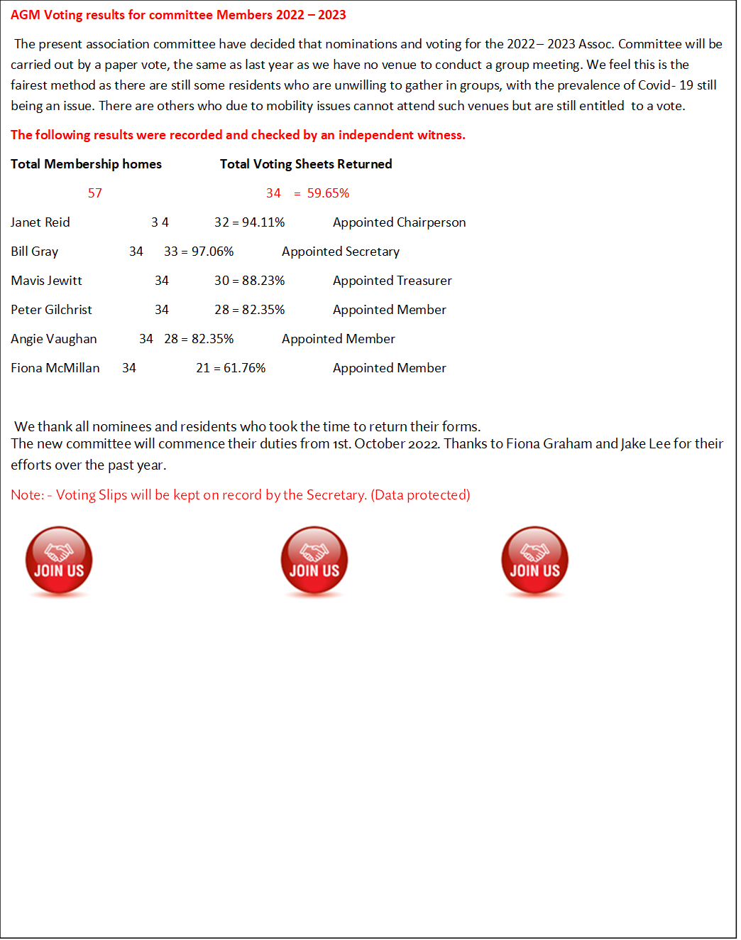

**The Community Garden** has had a reasonably successful season. Given that we are all amateurs and other family duties (including work) to keep us busy. We had a good crop of tatties, peas and cauliflowers. Other things, like the onions and or corn were not so productive. However, experienced gardeners assure us that it’s not just us. They also have suffered from the vagaries of the Scottish climate.

We have planted up some of the beds with a green manure mixture. So if you think they are weeds and need pulling out. Please Don’t. They will be dug into the bed in the spring to boost the soil.

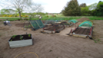

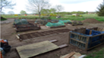

**Donations of £13.32 have been made to the Community Garden via the onsite donations box.**

Bonus ball winners last 4 weeks

10/09 No. 09 Fiona McMillan Findhorn Park £30

17/09 No. 15 Gordon Green Springbank £30

24/09 No.51 Fiona Graham Springbank £30

01/10 No. 21 Debbie Watson Grosvenor £30

**Dog Fouling** Maintenance staff have asked us to highlight a problem they are having with dog poo when strimming grass, this is more prevalent in the Findhorn Park area. It is the owner’

s responsibility to clean up after their dog. Letting them roam around the

residential areas unattended is against the park rules.

**Fires**. It has been reported by a resident that our farming” neighbour” has been burning materials, causing residents to close windows due to the smoke. The resident has discussed

this with the Fire Brigades and has been told that if concerned about a

 fire then call 999. They would rather react to a spurious warning then it be

left to become a more serious incident. Especially if you notice there is

no one attending the fire, or the smoke is other than grey or white.

 We are open to all ideas and thoughts for improving our Park environment, and residents wellbeing. Equally we are keen to have other contributors to the newsletter. Whether it’s a story, poem, experience, photo’s, recipies. Send all to:- [**mlreid@btinternet.com**](mailto:mlreid@btinternet.com)

Local places to visit

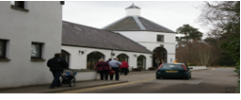**Brodie Countryfayre** is a retail emporium 4 miles west of

the park on the A96. They sell a wide range of clothing and

household goods. A large restaurant with outside seating

provides a full meal or light snack to enjoy.

OPENING HOURS

Open 09.00—5.00 Mon -Sat (June—Oct 5.30 close)

Open 09.30—5.00 Sun (June—Oct 5.30 close)

**Brodie Castle**. The longtime home of Clan Brodie,

this turreted 16th-century castle—now run by the National

Trust for Scotland—is set amid more than 170 acres

(70 hectares) of parkland. The restored interior offers a glimpse

into Brodie family life in the castle. Again, to be found four miles west of the park.

CASTLE AND CAFÉ Access to the castle is available only through guided tours at 11am, 1pm and 3pm. Please book your tour online in advance, or upon arrival at the Welcome Centre.

Opening Times - Current period: - 5 Mar–30 Oct, Wed–Sun, 10.00–16.00.

31 Oct–18 Dec, open for events only. 19 Dec–5 Feb 2023, closed

** RECIPIE**

Tagliatelle with “Hit-the-Pan” Salsa

Ingredients: -

115g/4oz fresh or dried tagliatelle

45ml/3 tbsp extra virgin olive oil

3 large tomatoes 1 garlic clove, crushed

4 spring onions, sliced 1 green chilli, halved, deseeded, and sliced

Juice of one orange 30ml/2 tbsp. chopped fresh parsley

Salt and ground black pepper Grated cheese to serve

Method;-

Cook the tagliatelle in salted boiling water until al dente. Drain and toss in a little of the oil. Season well.

Dip the tomatoes in boiling water for 45 seconds then into iced water. Then peel and chop them roughly.

Heat the remaining oil, until quite hot and stir-fry the garlic onions and chili

Add the tomatoes and orange juice and parsley. Season well, stir in the tagliatelle to reheat.

Serve with grated cheese.

**ENJOY**

USEFULL INFORMATION

As a residential Park Homeowner, you have several obligations to adhere to with regard to your property.

* Ensure your property is fully insured, see below.
* Your gas appliances are inspected once a year, and a compliance certificate is provided.
* Your electrical system must be inspected on a regular basis, this can be from 3 to 5 years depending on the age of your property. Again, a compliance certificate must be provided.

**It is imperative that anyone conducting any such inspections is fully certified/qualified to carry out such work. Anyone working on park home gas installations must be LPG qualified.**

**Similarly, anyone carrying out electrical inspections must be qualified to work on park home installations**

You may also find that your chosen insurer may require that your lodge/home be painted externally every so many years. Check your policy, it will outline their requirements. Every three years is the usual norm.

A copy of these documents should be given to the park Owners office, so that in the event of some disastrous consequences, there is a separate record to prove you are fully legally covered.

.

Park Home Insurance: Under the Mobile Homes Act 2013, All Residential Park Homes must be insured. Park Home insurance is not normally issued by normal insurance companies and has to be a policy specifically designed for residential park home and lodge owners.

Here are a list of Park Home Insurance Specialists….. Protect your property.

Park Home Assist <https://www.parkhomeassist.co.uk/>

Towergate Insurance <https://www.towergateinsurance.co.uk/>

Coast Insurance <https://www.coastinsurance.co.uk/>

Safeguard Insurance <https://www.safeguarduk.co.uk/>

PB Insurance <https://www.pbinsurance.co.uk/>

**These contacts are for information only. The final choice must be yours**.



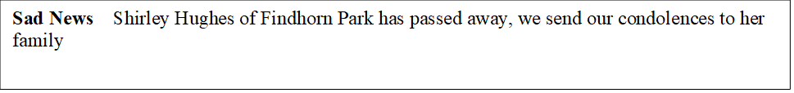

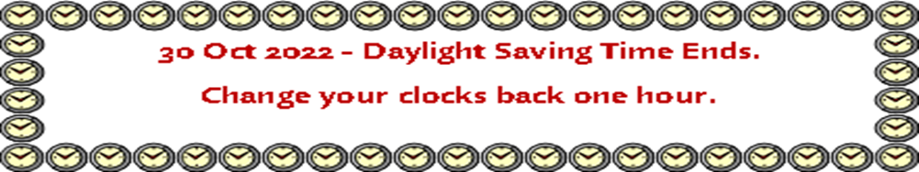

**Riverview Park Residents Association (RPRA)**

**Run by Residents for the Residents**

Membership is open to all home owning residents except for Riverview Country Park staff. RPRA has been recognised by Riverview Country Park owners as a Qualifying Residents Association.

As a member you will also have membership to the Scottish Confederation of Park Homes Residents Association (SCOPHRA) www.scophra.scot. SCOPHRA is a voluntary organisation who give expert advice on Mobile Home Law—Written Statements—Problem solving etc.

