|  |  |  |
| --- | --- | --- |
|  |  | |
|  | Riverview Park Residents Association | |
|  | e-Newsletter November 2022 | |
| **In This Issue**  e-newsletter :  Welcome to our  e-newsletter.  In a bid to cut down on paper and ink costs, also to reduce recycling, we are hoping that residents will use this version of newsletter. For residents who do not have internet access we still deliver a paper version so all residents on Riverview are kept up to date with onsite news.  Contact Us :  Secretary  Bill Gray 1 Grosvenor Park  Tel: 07872498494  billgray479@btinternet.com  **www.riverview-park-residents-assoc.com** |  | |
|  | |

Guy Fawkes 13 April 1570 – 31 January 1606), also known as Guido Fawkes while fighting for the Spanish, was a member of a group of provincial English Catholics involved in the failed Gunpowder Plot of 1605. He was born and educated in York; his father died when Fawkes was eight years old, after which his mother married a recusant Catholic. Fawkes converted to Catholicism and left for mainland Europe, where he fought for Catholic Spain in the Eighty Years' War against Protestant Dutch reformers in the Low Countries. He travelled to Spain to seek support for a Catholic rebellion in England without success. He later met Thomas Wintour, with whom he returned to England. Wintour introduced him to Robert Catesby, who planned to assassinate King James I and restore a Catholic monarch to the throne. The plotters leased an undercroft beneath the House of Lords; Fawkes was placed in charge of the gunpowder that they stockpiled there. The authorities were prompted by an anonymous letter to search Westminster Palace during the early hours of 5 November, and they found Fawkes guarding the explosives. He was questioned and tortured over the next few days and confessed to wanting to blow up the House of Lords.

Immediately before his execution on 31 January, Fawkes fell from the scaffold where he was to be hanged and broke his neck, thus avoiding the agony of being hanged, drawn and quartered. He became synonymous with the Gunpowder Plot, the failure of which has been commemorated in the UK as Guy Fawkes Night since 5 November 1605, when his effigy is traditionally burned on a bonfire, commonly accompanied by fireworks.



[This Photo](https://yournorthcounty.com/4th-of-july-fireworks-san-diego-north-county/) by Unknown Author is licensed under [CC BY](https://creativecommons.org/licenses/by/3.0/)



**A bonfire and fireworks display will go ahead this year, the Rotary Club of Forres has confirmed. The date set for this is 5th. November and the bonfire will be lit at 6:30pm. It will be held in Grant Park**.

Uncontrolled Firework parties/displays are potentially dangerous. Remember we live in the country and farm animals are close by, as are your neighbors’ cats and dogs. If you feel the need to “do your own thing” let the neighbor’s know, so they can protect their pets.

***Better still just go to an organised display.***

**Community garden.**

We have almost come to the end of the growing season, with just the sprouts and other brassicas remaining. Some beds have been planted with green manure, which when it appears next spring will be dug into the beds to provide healthy fodder for the bed. The herbs are doing well and are available for all to share.

We have been very fortunate in that we have had loads of tools etc donated. Including fruit cages, barrows, outdoor heaters, benches, compost bins, plant pots, shelving, and many other items all handy for the garden.

The one thing we have been short on is volunteers, you don’t need to be a expert there are plenty with good ideas around who will help and guide you if you are unsure about what to do. Or just come along and have a blether in the sunshine.

**Bonus Ball Winners- past four weeks**

8/10 No 51 Fiona Graham Springbank £30

15/10 No 39 Pam Armstrong Grosvenor £30

22/10 No 34 Donna Goddard Rowan Cres. £30

29/10 Roll Over

We are open to all ideas and thoughts for improving our Park environment. Equally we are keen to have other contributors to the newsletter. Whether it’s a story, poem, experience, photo’s, recipies.

Send all to:- [mlreid@btinternet.com](mailto:mlreid@btinternet.com)

We can offer residents space on our web site. To Buy & Sell items they no longer need. We can upload photos, details to the association website. Just click on the Buy & Sell button on the web site.Or click on www.riverview-park-residents-assoc.com/buy-n-sell.

RPRA is not responsible for any items sold through this process. This is purely between buyer and seller.

**Culbin Sands, Forest**

 Is a huge area of coast and countryside and an SSSI (site of special scientific interest) in Moray, Scotland, stretching from just east t of the town of Nairn eastwards to the village of Findhorn and its bay. All of the areas are very important for wildlife in general and are strongly protected by law. A village of Culbin existed in this area until it was wiped out entirely during a severe sandstorm of 1694.

**Findhorn Bay**

Findhorn Bay is an enclosed estuary giving shelter to people and wildlife. The Bay is nationally important for birds with significant numbers of migrant wildfowl and waders. It is also important for water sports and as a tourist destination. Established in 1998 the Local Nature Reserve is managed by local people in partnership with Moray Council and Scottish Natural Heritage

**Randolph’s leap**

Is known for its fast-flowing water and dramatic rock formations, but it is also a very important wildlife area, home to red squirrels, woodpeckers and black-backed gulls. The river flows north and terminates in Findhorn Bay and finally at Findhorn Beach, both areas of outstanding [Grab your reader’s attention with a great quote from the document or use this space to emphasize a key point. To place this text box anywhere on the page, just drag it.]

ding natural beauty.

**Walking in the area.**

There are many walking paths in the area, including Along the banks of the Findhorn. Expert information can be had at a local site **www,forresfootpathtrust.org.uk**. They welcome new members contact through their website

**Cullen Skink**  

Ingredients 1 small onion, 25g butter, 300 ml milk 80ml double cream, 1 bay leaf, 240 g undyed smoked haddock, 180g mashed potatoes, 20ml peaty malt, Salt & pepper, 1tbsp finely chopped chives.

Method Soften the onion in the butter at a gentle heat. Add the milk and cream, bay leaf and bring to the boil.

Add he fish and poach for 5 minutes until barely cooked. Remove the fish and flake it using a fork.

Whisk in the mash and season, bringing it back to a simmer, then add the whisky. Put fish back in and warm through. Adjust seasoning, divide into bowls, and top with chives. Serve with a dram and crusty bread.

**Cranachan** 

2 tbsp medium oatmeal,300g fresh British raspberries, a little caster sugar, 350ml double cream (we used Jersey double cream) 2 tbsp heather honey, 2-3 tbsp whisky, to taste.

**Steps:** To toast the oatmeal, spread it out on a baking sheet and grill until it smells rich and nutty. It will not darken quickly, so use your sense of smell to tell you when it is nutty enough. Cool the oatmeal.

Make a raspberry purée by crushing half the fruit and sieving. Sweeten this to taste with a little caster sugar. Whisk the double cream until just set, and stir in the honey and whisky, trying not to over-whip the cream. Taste the mix and add more of either if you feel the need.

Stir in the oatmeal and whisk lightly until the mixture is just firm. Alternate layers of the cream with the remaining whole raspberries and purée in 4 serving dishes. Allow to chill slightly before eating.

**Winter Fire Safety Advice.** As some of us will be lighting our fires more often, it is recommended that the chimneys are swept at least once a year and that a carbon monoxide detector is fitted. Always check the detector to ensure it is working and, give it a clean as dust and insects can gather.

Unplug fairy lights and other electrical goods such as phone chargers etc when you go to bed or are leaving the home unattended for a period of time.

Do not leave cooking unattended and do not cook whilst under the influence of alcohol, as most home fires start in the kitchen.

**USEFULL INFORMATION**

As a residential Park Homeowner, you have several obligations to adhere to with regard to your property.

* Ensure your property is fully insured, see below.
* Your gas appliances are inspected once a year, and a compliance certificate is provided.
* Your electrical system must be inspected on a regular basis, this can be from 3 to 5 years depending on the age of your property. Again, a compliance certificate must be provided.

**It is imperative that anyone conducting any such inspections is fully certified/qualified to carry out such work. Anyone working on park home gas installations must be LPG qualified.**

**Similarly, anyone carrying out electrical inspections must be qualified to work on park home installations**

You may also find that your chosen insurer may require that your lodge/home be painted externally every so many years. Check your policy, it will outline their requirements. Every three years is the usual norm.

A copy of these documents should be given to the park Owners office, so that in the event of some disastrous consequences, there is a separate record to prove you are fully legally covered.

.

Park Home Insurance: Under the Mobile Homes Act 2013, All Residential Park Homes must be insured. Park Home insurance is not normally issued by normal insurance companies and has to be a policy specifically designed for residential park home and lodge owners.

Here are a list of Park Home Insurance Specialists….. Protect your property.

Park Home Assist <https://www.parkhomeassist.co.uk/>

Towergate Insurance <https://www.towergateinsurance.co.uk/>

Coast Insurance <https://www.coastinsurance.co.uk/>

Safeguard Insurance <https://www.safeguarduk.co.uk/>

PB Insurance <https://www.pbinsurance.co.uk/>

**These contacts are for information only. The final choice must be yours**.

**Winter Fire Safety Advice.** As some of us will be lighting our fires more often, it is recommended that the chimneys are swept at least once a year and that a carbon monoxide detector is fitted. Always check the detector to ensure it is working and, give it a clean as dust and insects can gather.

Unplug fairy lights and other electrical goods such as phone chargers etc, when you go to bed or are leaving the home unattended for a period of time.

Do not leave cooking unattended and do not cook whilst under the influence of alcohol, as most home fires start in the kitchen.

**Photo competition**

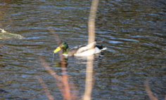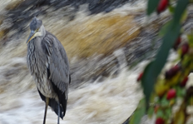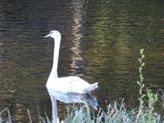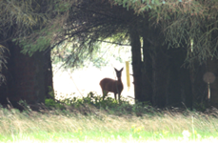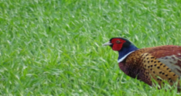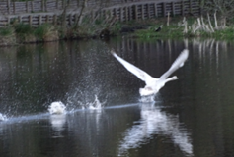

A selection of mostly local photos. Perhaps others would like to submit their efforts to the newsletter. If we get enough perhaps, we could have a competition for the best and solicit a wee prize out of the Association. Send as .jpg to [mlreid@btinternet.com](mailto:mlreid@btinternet.com). Thanks.

**Park announcements**

**New Residents WELCOME**



To Mark & Mary-Ann 1 Rowan Road.

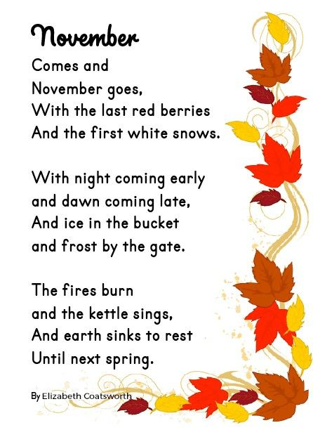

**SEPTIC TANK**

**The Findhorn/Grosvenor septic tank has been BLOCKED AGAIN by wipes.**

**This must stop.**

**Items such as paper towels, wet wipes (even flushable ones), Sanitary products, disposable nappies, dental floss, cotton buds, cigarette butts, food, grease, cooking oils, cat litter, coffee grounds, plastics, solvents, paints, paint thinners.**

**If in doubt don’t take the chance**.

  

**Riverview Park Residents Association (RPRA)**

**Run by Residents for the Residents**

Membership is open to all home owning residents except for Riverview Country Park staff. RPRA has been recognised by Riverview Country Park owners as a Qualifying Residents Association.

As a member you will also have membership to the Scottish Confederation of Park Homes Residents Association (SCOPHRA) www.scophra.scot. SCOPHRA is a voluntary organisation who give expert advice on Mobile Home Law—Written Statements—Problem solving etc.

